Design Document

**Group:** Andre Titus, Jaiden Moore, Maxwell Montes Diaz

**High concept:** In this game called Road Rally (may change) you control a car and drive around a track to get the best lap time.

**Backstory:** The currency in this game when, not on the track, is how many miles you can rack up and spend those miles for things on your own time. So, for this gig you’re in it for the money(miles).

**Features:** Main menu, UI, a track, a timer, and a couple abilities for the car to get past the race track.

**Gameplay experience:** All you do is control a car and drive around a track.

**Functionality:** Same functionality as if you were to play a simple arcade racing game.

**Controls:** The controls can be keyboard or controller. On keyboard wasd or arrow keys and a couple more buttons. On the controller it would be the standard buttons.

**Art style:** It is going to be pretty blocky like Roblox. Simple primitive shapes. Really colorful.

**Visual concept development:** 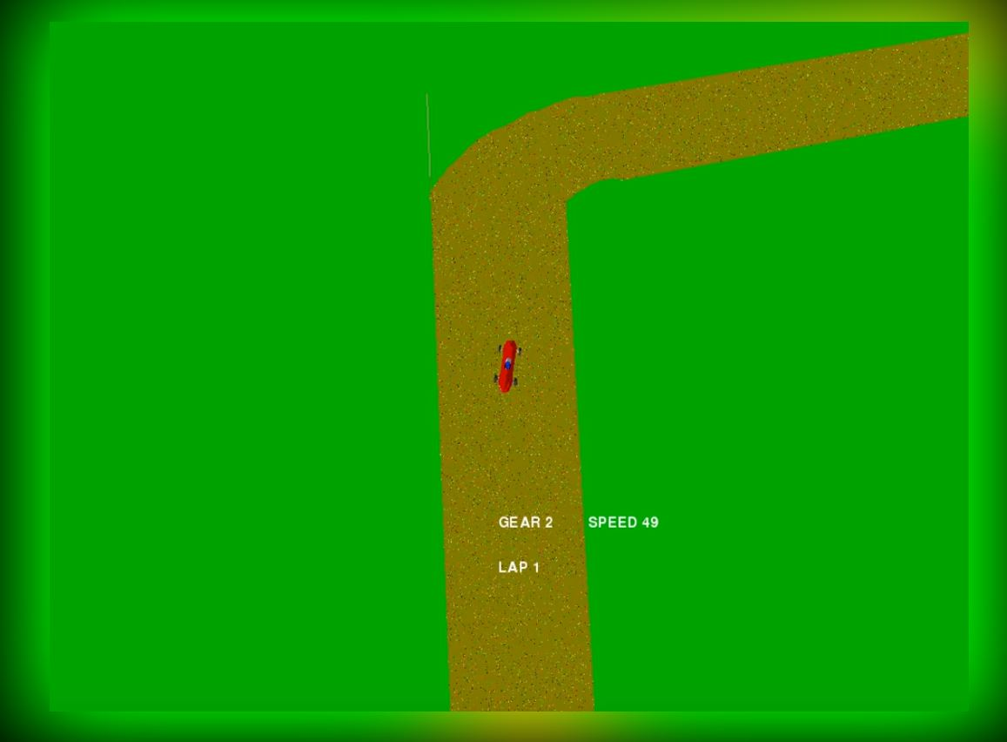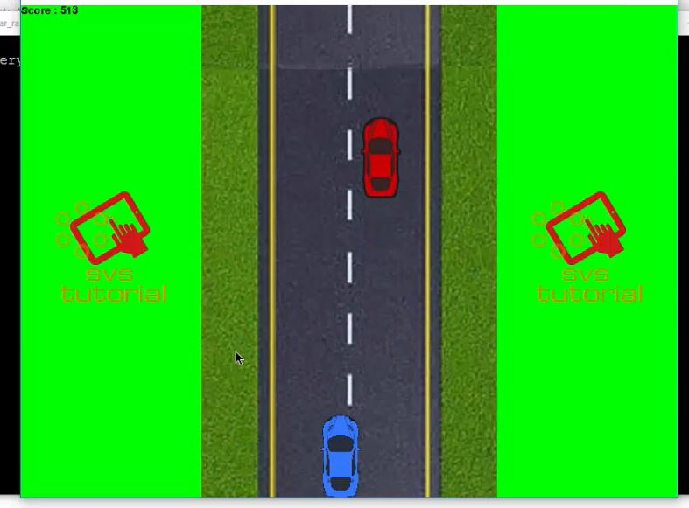

**Risks:** Engine problems, python experience, engine experience, time

**Production schedule:** We should have something new every week or close to it.